**BUSINESS ETHICS AND CORPORATE GOVERNANCE**

**BCAMS381**

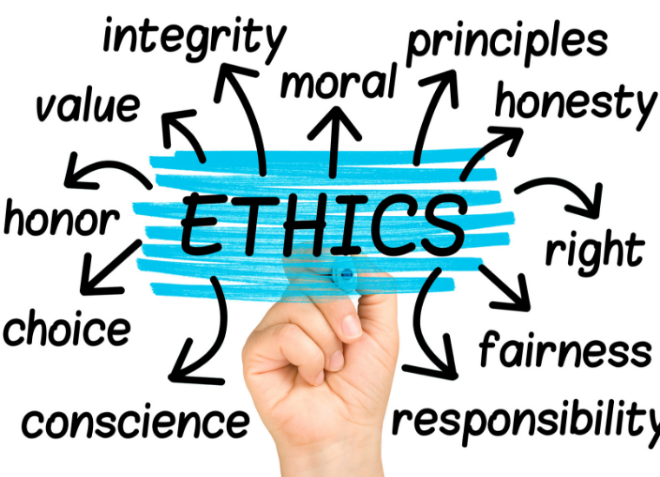

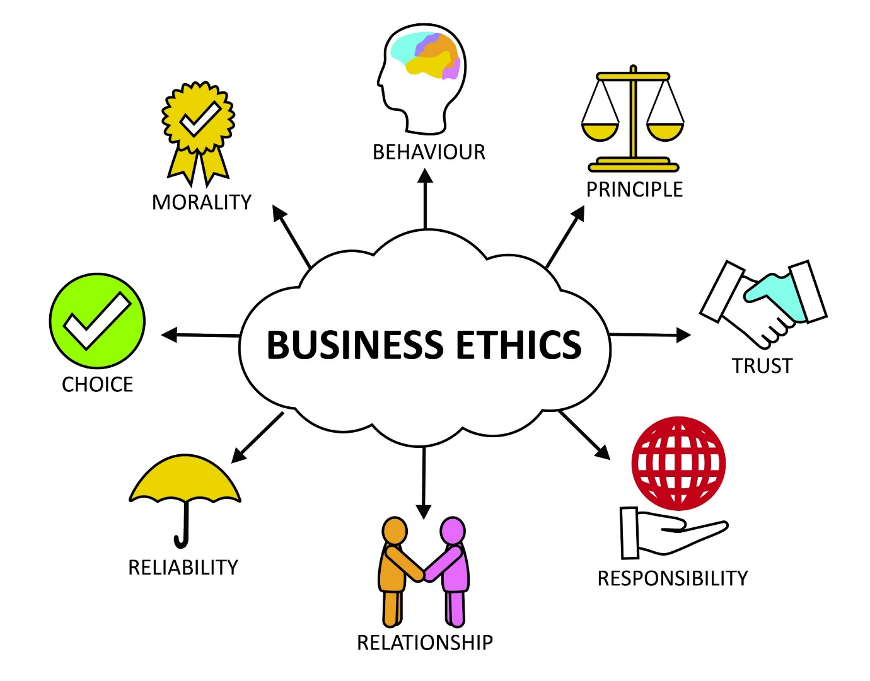

**"Ethics” derived** from: Greek word: **ethos** (character),

Latin word **mores** (customs).

Ethics defines how individuals choose to interact with one another.

**“Business”**: Old English ‘**bisignes**’:**“engaging in**

**work”.**

Cambridge dictionary defines business ethics as,

“the rules, principles, and standards of deciding what is morally right or wrong when working.”

BUSINESS ETHICS
MEANING:
Business Ethics is a specialized study of moral, right or
wrong in a business. It defines written and unwritten codes of
principles and values that govern decisions and actions within a
company. In the business world the organizations culture sets
standards for determining the difference between good and bad
decision making and behavior.
“Business ethics is the study of the standards of business behavior which promote
human welfare and the good."
Kirk O. Hanson
 

**Business ethics**

Business ethics is a form of applied ethics or professional ethics, that examines ethical principles and moral or ethical problems that can arise in a business environment. It applies to all aspects of business conduct and is relevant to the conduct of individuals and entire organizations.

*Emotional Intelligence in Corporate Offices*

**Ranbir is the Chief executive officer of a company. The Company has been growing and has recruited quite a few specialists recently. The functional heads in the company have to meet their staff in an open meeting every two months. Ranbir detested these meetings. It was open to everyone in the office. The staff came up with a long list of trivial and tiresome complaints and grievances. They repeated the same things and spoke at length. Even when the staff knew of the constraints, they went on with their complaints. They wanted more space for lounge, for bathrooms. Ranbir pointed to lack of space, and yet the staff continued to complain. Ranbir cultivated a habit of sitting through the meeting with a cheerful face, but with his mind switched off from the proceedings. The meeting became a tiresome ritual he had to get through.**

**Due these issues many employees had left the company and its further hampering the Business of the company.**

Q. In Ranbir’s situation what action would you have taken and why?

Answer

The question focuses on understanding the needs of a team and the leader’s role in resolution of mundane problems of the team members. The source of the problem in this case is perhaps rooted in the fact that success of the company has brought forth induction of new team members and the present accommodation has thereby become inadequate and the situation had become worse due to Ranbir's attitude towards the grievances of the employees, lackadaisical approach towards the meeting with the employees.

Stakeholders involved in the case are:

Company’s Ceo

Employees of the Company

New & old employees

Shareholders of the Company

**The situational challenges that are faced by the CEO are:**

**Crisis Management**: Handling crisis efficiently with limited resources and without or minimum adverse effects on the employees.

Timely decision making to prevail the healthy work culture in the office and trust among the public for efficient decision making.

**Conflict management**: Conflict management is another skill that managers need. The conflicts here mean the quarrels and disputes which frequently arise in organizations.

**Ethical Components that could be utilised:**

**Emotional Intelligence**: Emotional intelligence refers to ‘the ability to identify one’s own emotions and those of others, harness and apply them to tasks, and to regulate and manage them.

**Emotional Quotient** (EQ): It is a measure of one’s EI i.e., through a standardized test, one’s awareness of emotions in relation to self and others is known.

**Empathy**: It is an awareness of the needs and feelings of others both individually and in groups, and being able to see things from the point of view of others.

**Social Skills**: It is applying empathy and balancing the wants and requirements of others with one’s. It includes building good rapport with others.

**CEO’s course of action to resolve the issue,**

**Concrete Plan of Action:**

Since the business of the company is thriving and more specialist staffers have been recruited, Ranbir should quickly look for a bigger and better workplace.

**If employees still face issue**:Till such time that office expansion takes place relieving the pressure on facilities, he can take some small steps like:

**Cleaning Toilet**: Taking very small steps to impress the employees like cleaning toilet on regular basis, but the problem is of space and not cleanliness, this step could impress the employees for few days but it would not be the final solution.

**Attentive listening**: By Carefully listening to the employee’s and then solving their problem are marks of sincere concern for any individual or group as a whole. Leaders in office need to show this quality. So, he has to be attentive however much he dislikes the grievances or narration thereof in the meetings.

He need not switch off in the meeting, rather he should listen to the grievances of the employees more empathically. These meetings serve a purpose. If he ignores all that the staff members have to say, the present employees could also resign. He has also to be responsive to what staff members say.

**Ignoring their Demands**: He can ignore their demand and work as nothing has happened, but this step could hamper the productivity and future prospect of the company.

**Work from Home alternative**: This step could be the possible alternative, as by providing hybrid model of work, it will ease the problem of space as employees can easily work from home and some employees can still come to office, so it eases the pressure on the office infrastructure.

**Allocation of office space on rent**: By allocating a separate rental office space nearby only for temporary period till the proper office space is not required could solve the problems of faced by employees and satisfy all the parties to the dispute.

**Conclusion**

The conflict can only be resolved through the collective effort by all the stakeholders involved in the situation, where the company need to take initiatives to improve emotional intelligence, empathy and emotional quotient among its CEO, employees and other staff, so, there could be an open discussion and employees can freely express their concerns and CEO and management of the company should listen to the problems more attentively and should take proper measures to address the issues in due time.

**OBJECTIVES**

* Kindness,
* Fairness,
* Honesty

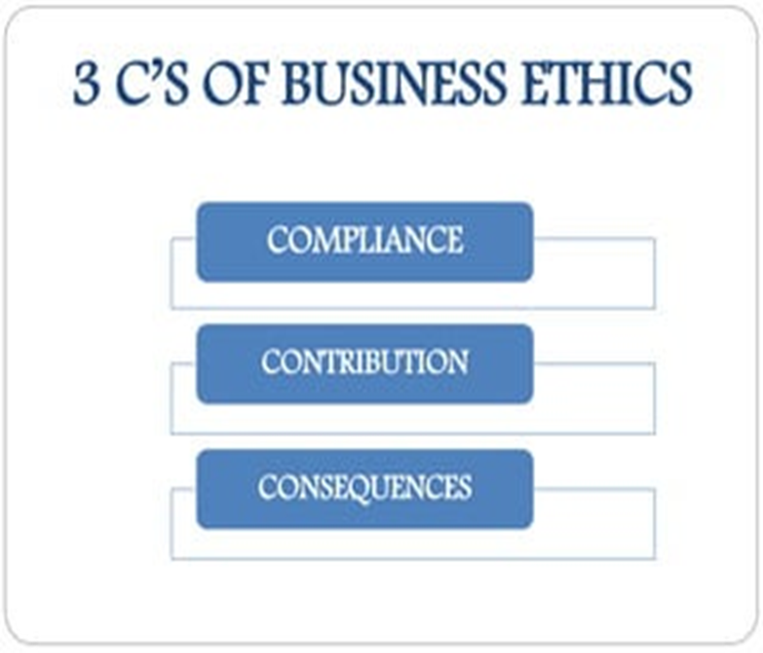

NATURE OF BUSINESS ETHICS
• Deals with human conduct
• Creates goodwill to maximize profit
• Earns loyalty and commitment of customers and employees
• Brings together desired moral values and corporate interests
• Success in the long term
 

**Characteristics**

* Discipline
* Ancient Concept
* Personal Dignity
* Related to Human Aspect
* Study of Goals and Means
* Different from Social Responsibility
* Greater than Law

**Principles**

1. HONESTY

2. FAIRNESS

3. LEADERSHIP

4. INTEGRITY

5. COMPASSION

6. RESPECT

7. RESPONSIBILITY

8. LOYALTY

9. LAW-ABIDING

10. ACCOUNTABILITY

11. TRANSPARENCY

12. ENVIRONMENTAL CONSCIOUSNESS